TAKE-BACK OF WASTE ELECTRICAL EQUIPMENT

We are committed to environmentally responsible behavior and therefore provide you with simple and free-of-charge options for disposing of your end-of-life electrical equipment.

Consumers play a crucial role in the system for handling electrical appliances. It is up to them to decide what to do with an old appliance. Obsolete and unwanted electrical equipment does not belong in unsorted municipal waste—instead, it should be handed over through designated collection points, known as take-back points, from where it is sent for reuse or recycling.

Consumers must be informed—by means of the symbols below—that the electrical equipment in question must not be disposed of with household waste. All new electrical devices are marked with such symbols. The symbol may appear directly on the device, on its packaging, or in the user manual or warranty certificate.

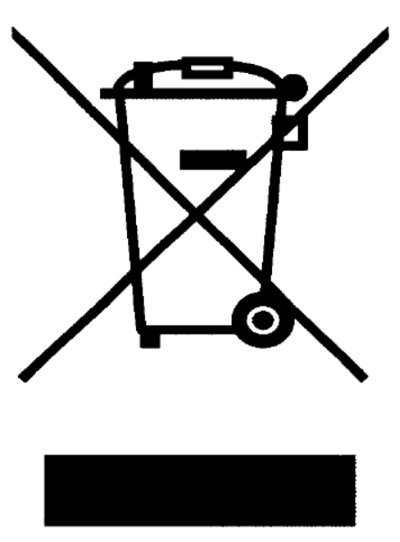 | 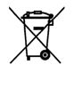
Symbol 1 | Symbol 2

How to dispose of an old appliance?

- Private individuals can use the services: BUĎ LÍNÝ or Rebalík
- Legal entities can use: Svoz pro registrované partnery
- At the point of sale at the address of a physical store: [retain this option and add the address if your premises serve as a take-back point in cooperation with REMA Systém, a.s.]
- Via the public collection network of REMA Systém, a.s., intended for take-back of electrical equipment
- Via the public collection network listed on the website of the Ministry of the Environment (ISOH 2)
- If needed, you can seek advice on the free hotline of Smart Recycling: 800 976 679

Why recycle?
Electrical appliances contain many recyclable materials such as plastics, glass, and metals (zinc, iron, manganese, nickel, cadmium, lead etc.). Some of these substances are highly hazardous to the environment and human health, especially mercury, lead, and cadmium.

By handing over electrical equipment to a take-back point, we help conserve primary raw material resources through recycling and simultaneously protect the environment from potential harm caused by improper disposal.

Improper disposal of this type of waste may be subject to fines in accordance with national regulations.

